|  |  |  |  |  |  |  |  |
| --- | --- | --- | --- | --- | --- | --- | --- |
| |  |  |  |  | | --- | --- | --- | --- | | |  |  | | --- | --- | | |  | | --- | | Magnitude Shift in the role of HR given the Brave New World When: 21 Sep 2022 9:00 AM, PDT Where: Zoom event  **EVENT DETAILS:**  Diagram  Description automatically generated  Since 2020, the role of the HR Professional has shifted and become front and center in helping corporations navigate the new demands brought about by the pandemic, social unrest, an aggressive turn in the job market and a new generation of employees with new expectations.  CEO’s have become dependent on the HR Leaders to give guidance, set direction and navigate their organizations in a complex world.   HR Leaders have become experts without training in areas not foreseen as being corporate issues to navigate.   The respect and dependence on HR professionals who can flex, learn and apply change is the new world of HR!  Let’s reflect on where we’ve been, let’s celebrate what we have accomplished and let’s talk about what’s expected of us going forward and how we can support each other to lead HR and our organizations in this Brave New World.  We will hear from line management on what they have seen and appreciated from their HR Counterparts. What they expect going forward. Let’s hear from HR Leaders who were in the thick of the change. Let’s talk with HR Advisors who helped coach and guide our internal HR Team members.   What did they see, what could we have done differently, what do we need to prepare for going forward. Join us!  **Program Moderator:** [Dena House](https://www.linkedin.com/in/dena-house-4163b62) - SVP of HR, OD & Learning at Adverum Biotechnologies, Inc  **Panel Speakers:**  **Reema Batnagar**  VP, Human Resources, Pixar Animation Studios  Reema Batnagar joined Pixar Animation Studios in February 2019 as Vice President, Human Resources. In her role, Batnagar is responsible for leading Pixar’s human resources department, which includes talent acquisition, leadership/organizational development, total rewards, and employee relations.  Batnagar brings over 20 years of HR experience to the job. Prior to Pixar, Batnagar worked at Sony Interactive Entertainment as Head of HR for Sales & Marketing, where she led learning and development and talent management. She has also held a variety of senior HR leadership and organizational development roles at VMware, Adobe, and Intuit.  Growing up in St. Paul, Minnesota, Batnagar holds a bachelor’s degree in communications and psychology from St. Olaf College and a master’s degree in human resources and organizational development from University of Minnesota.  **Sahar Zandi**  Head of Human Resources and Chief of Staff  [Sahar Zandi](https://www.linkedin.com/in/sahar-zandi/) joined Clear Labs in June 2018.   Sahar is a versatile and proven Human Resources Executive and Chief of Staff. With an MS in counseling, she was able to focus on data driven analyses and employee life cycle development. Her ability to combine her background expertise with sharp business acumen allows her to flex in her role as Head of Human Resources and as Chief of Staff. She brings an innovative and human centered approach to her work. | | |  | | |  | | --- | |  | |  | |

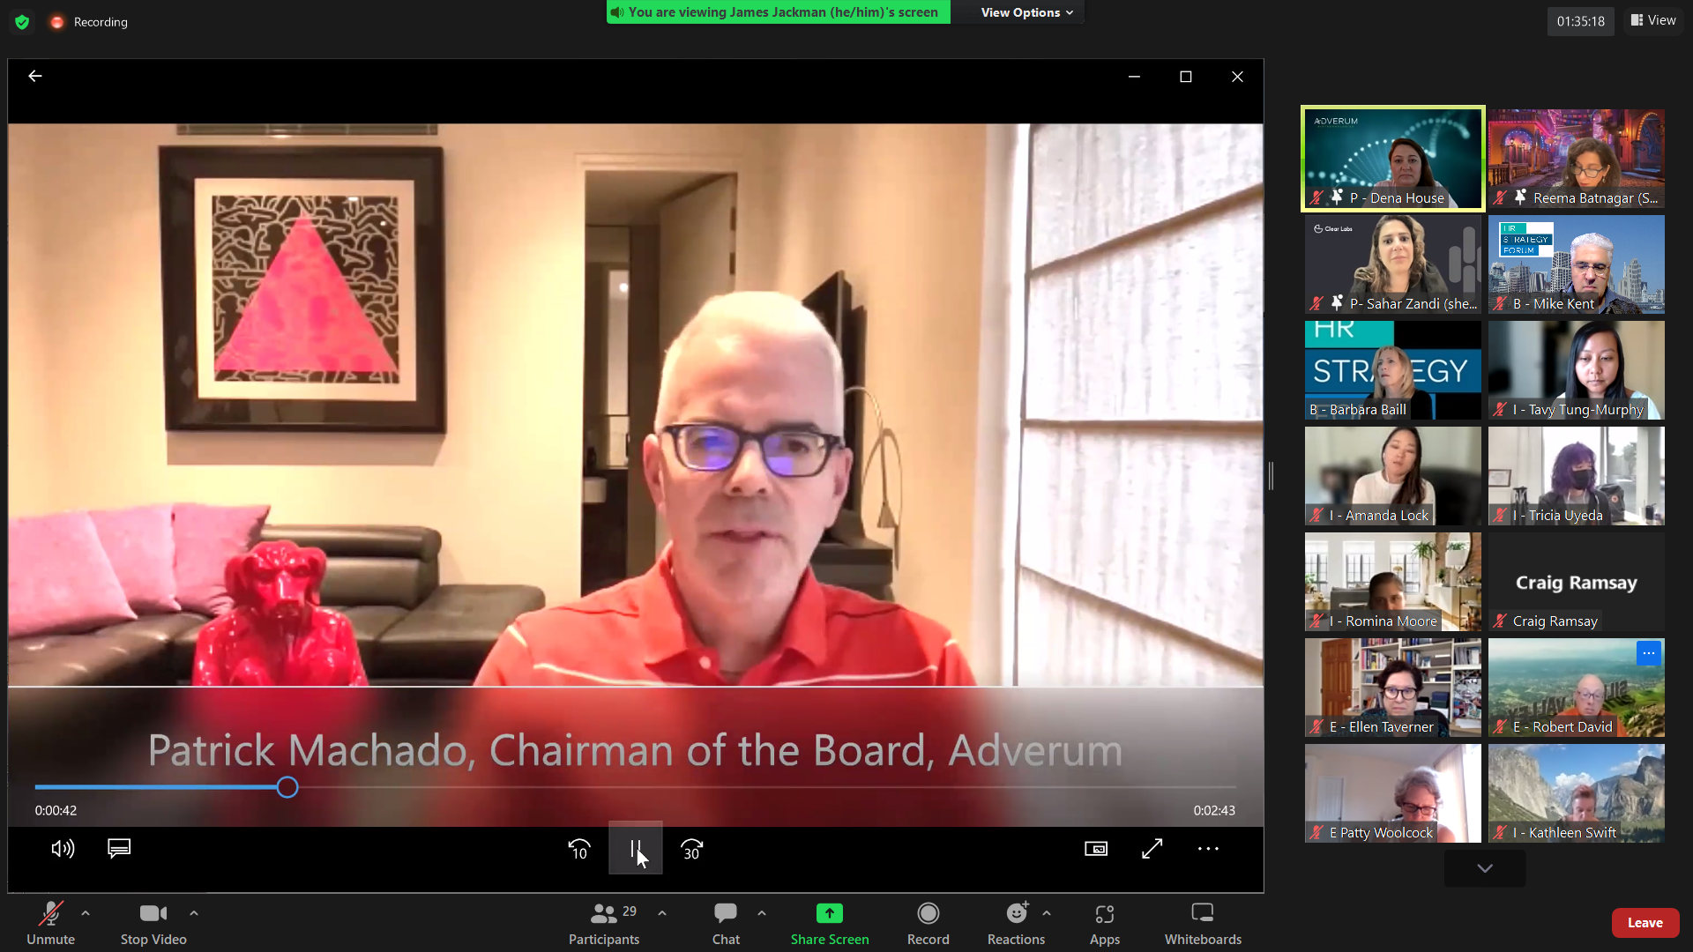

**Transcript of Chat**

09:03:39 From B - Barbara Baill to Everyone: Input your name, company, email (if comfortable) and whether you are internal HR or external to an organization into CHAT. Thanks!

09:04:23 From E - Pam Brown / hrQ to Everyone:good morning! pam brown, hrQ, pam@hrqinc.com

09:04:23 From iCharlotte Bachelor to Everyone:Charlotte Bachelor - MacPherson's

09:04:23 From E- Annie Collins to Everyone:Annie Collins - Executive Recruiter, Westwood & Wilshire annie@westwoodwilshire.com

09:04:24 From Luke Morgan to Everyone:Good Morning! Luke Morgan @ Pixar

09:04:27 From Kristina Civille to Everyone:Hi I am Kristina from AccelPeople kristina@accelpeople.com

09:04:27 From E - Ellen Taverner to Everyone:Ellen Taverner - External - Prime Chief of Staff

09:04:31 From I Wendy Chang to Everyone:Wendy Chang Harpoon Therapeutics wchang@harpoontx.com

09:04:33 From B - Barbara Baill to Everyone:As we wait to get started: What word(s) would you use to describe your current thoughts about your HR team and its contributions during the pandemic?

09:04:35 From E Patty Woolcock to Everyone:Patty Woolcock, Woolcock Consulting, patty@woolcockconsulting.com

09:04:43 From Ashley Robertson to Everyone:hi everyone! Ashley Robertson - People Partner @ Pixar

09:04:43 From Jennylyn Huynh to Everyone:Hi everyone! Jennylyn Huynh, Pixar

09:04:50 From Amanda Lock to Everyone:Amanda Lock, Clear Labs

09:04:54 From Valerie Junger (she/her) People and Places at Quantcast to Everyone:Valerie Junger, CPO, Quantcast.

09:04:55 From Vicki Arnold to Everyone:Hi everyone. Vicki Arnold. svarnold57@gmail.com. Recently retired.

09:05:07 From Wendy Tanzillo (she/her) to Everyone:Hello, Wendy Tanzillo at Pixar

09:05:08 From Tavy Tung-Murphy to Everyone:Good morning all! Tavy at Clear Labs

09:05:09 From Tess Hebert to Everyone:Tess Hebert - Kinevant Sciences - HR Manager

09:05:12 From E-Andrea Tegstam to Everyone:Good morning! I'm Andrea Tegstam, Sr Exec Recruiter with Westwood & Wilshire, andrea@westwoodwilshire.com

09:05:13 From E-Sue Bethanis, mariposa to Everyone:Hi everyone, nice to be here. Sueb@mariposaleadership.com

09:05:16 From B - Barbara Baill to Everyone:Hi, all! Barbara Baill Executive Coach and Chair of HRSF Experience Creation Team

09:05:31 From B - Mike Kent to Everyone:HRSF Board Member, Mediator, Executive Coach and HR Consultant

09:05:39 From B - Mike Kent to Everyone:mlkent12@gmail.com

09:05:53 From Robert David to Everyone:Robert David Executive Dir CSHRP

09:05:55 From Valerie Junger (she/her) People and Places at Quantcast to Everyone:Cultural glue

09:05:57 From B-Shreya Sarkar to Everyone:Shreya Sarkar - Human Capital Growth, shreya@humancapitalgrowth.com

09:06:01 From B - Barbara Baill to Everyone:What word(s) would you use to describe your current thoughts about your HR team and its contributions during the pandemic?

09:06:20 From E- Annie Collins to Everyone:Shift

09:06:27 From B - Barbara Baill to Everyone:Name, Company, Company, Email, and Internal or External

Rename yourself, place an “I” if internal or an “E” if external in front of your name.

09:08:55 From B - Barbara Baill to Everyone:What word(s) would you use to describe your current thoughts about your HR team and its contributions during the pandemic?

09:13:34 From B - Barbara Baill to Everyone:I think HR are exhausted and challenged yet keep innovating with the changing demands of the workforce and executive leaders.

09:23:23 From B - Barbara Baill to Everyone:We really want today to be interactive. Please add your comments and questions in chat and we will be monitoring the chat to capture your thoughts.

09:26:09 From I - Valerie Junger (she/her) People and Places at Quantcast to Everyone:What flexible/responsive ideas did you bring forth, Reema and which one was most impactful?

09:26:57 From E- Annie Collins to Everyone:How did you work to engage, retain, and recruit talent during the shift to Hybrid work?

09:27:12 From I - Valerie Junger (she/her) People and Places at Quantcast to Everyone:Reema, how was HR perceived prior to you joining Pixar?

09:27:54 From I - Valerie Junger (she/her) People and Places at Quantcast to Everyone:

Any great tips you care to share ton how you are successfully onboarding new hires in the new hybrid world?

09:27:56 From B - Lori Heffelfinger to Everyone:All - we need you to rename yourselves I - for Internal HR Leader especially. If you need help doing this - I can do it for you.

09:34:52 From E Kerry-Lee Hannon to Everyone:I love this Reema, so interesting to hear how you have tacked these areas.

09:36:48 From B - Lori Heffelfinger to Everyone:three dots in your box. Are you internal or external?

09:36:59 From B - Jeanne Schad to Everyone:Resilience is an important theme here.

09:38:18 From B - Barbara Baill to Everyone:Reema: can you give an example of how you leaned into data with the Executive Team?

09:40:08 From B - Jeanne Schad to Everyone:Brilliant idea - "Messy filmmaking" used to define hybrid rules.

09:47:59 From B - Jeanne Schad to Everyone:@Reema, with the values you rolled out during the pandemic, do you find they still apply today?

09:51:54 From B - Barbara Baill to Everyone:Instructions for Breakouts:

Introductions: Who you are, where you work/your role? What are you most proud of having accomplished in the last 3 years? (for yourself or your HR team) If you knew then what you know now, what advice would you give to yourself?

10:15:03 From B - Barbara Baill to Everyone:What are you most proud of?

10:15:22 From E - Michael Grove to B - Mike Kent(Direct Message):Hi Mike, how have you been? We are doing a Disrupthr event on Nov 9th. Mike

10:19:16 From I - Ashley Robertson to Everyone:+1 Kathleen

10:24:18 From B - Jeanne Schad to Everyone:Advice: patience

10:24:19 From B - Vicki Arnold to Everyone:Stay calm

10:24:23 From P- Sahar Zandi (she/her) to Everyone:"hang in there!”

10:24:33 From B - Barbara Baill to Everyone:What advice would you have given to yourself?

10:24:33 From B - Vicki Arnold to Everyone:Take care of myself and recognize the toll it was taking.

10:24:40 From I - Kathleen Swift to Everyone:Less is more

10:24:44 From E - Robert David to Everyone:It's World Gratitude Day today! #begrateful

10:24:46 From I - Kathleen Swift to Everyone:Meet people where they are

10:24:52 From E Patty Woolcock to Everyone:Plan for long term

10:24:52 From B - Barbara Baill to Everyone:Find joy in the moment

10:24:56 From I - Valerie Junger (she/her) People and Places at Quantcast to Everyone:Listening and pivoting to meet ee needs

10:25:00 From E - Ellen Taverner to Everyone:Be opportunistic, e.g., launch employee surveys to create more metrics for exec team

10:25:08 From B - Lori Heffelfinger to Everyone:One Step at a Time - know you can do this - with support

10:25:10 From I - Kathleen Swift to Everyone:don't underestimate time

10:25:21 From I - Maureen Aryee to Everyone:Empathy! Empathy! and more empathy!

10:25:34 From E - Robert David to Everyone:+1 Maureen

10:25:51 From B - Barbara Baill to Everyone:make time for connections

10:27:03 From I - Valerie Junger (she/her) People and Places at Quantcast to Everyone:

Create online opportunities for ees to connect in a fun way cross geos and cross functions.

10:33:40 From I - Valerie Junger (she/her) People and Places at Quantcast to Everyone:

I'm going to shave off a few years myself based on your advice Sahar!

10:34:07 From P- Sahar Zandi (she/her) to Everyone:haha, pandemic time doesn't count! 😄

10:38:24 From E - Robert David to Everyone:

Nice metaphor for leadership - the cake, the icing, and the cherry on top!

10:39:31 From E Kerry-Lee Hannon to Everyone:love this metaphor!!

10:40:18 From B - Lori Heffelfinger to Everyone:

Sounds like Pat wants to be challenged and to challenge his executives. Tricky.

10:40:53 From E - Michael Grove to B - Mike Kent(Direct Message):Thanks

10:46:11 From E - Michael Grove to Everyone:Wow - I fully support that comment. There is NO going back unless a big price will be paid. The key is to help the C suite understand that by giving choice they can get back a trusted and predictable performance. There needs to be a new paradigm get release the current stress and get to a more humancentric means of managing the work .

10:47:23 From E - Tawny Lees to Everyone:Curious what HR leaders are doing to develop their HR talent? Seems many opportunities for support and growth - to being even more courageous, strategic, influential.

10:47:58 From E Kerry-Lee Hannon to Everyone:love that point Patty!

10:48:18 From E - Michael Grove to Everyone:Agree. That is the path to the needed transformation

10:48:54 From P- Sahar Zandi (she/her) to Everyone:great point, Patty!

10:49:25 From P- Sahar Zandi (she/her) to Everyone:really good question, Tawny-a few things we're working on is creating our DEIB council and additional ERG groups

10:49:35 From P- Sahar Zandi (she/her) to Everyone:Skip level meetings

10:49:40 From I - Valerie Junger (she/her) People and Places at Quantcast to Everyone:For me the future is about redefining the employee value proposition from making your life fit into your work to making your work fit into your life. So from an HR perspective it's about creating an experience where employees feels supported, cared for, invested, etc.

10:51:34 From B - Barbara Baill to Everyone:

Please vote now. If you are External, what are you hearing from the organizations you are working with?

10:52:15 From B - Wally Kuhns to Everyone:Sahar - 18 mos. (average) employee stint, that's wild

10:52:41 From P- Sahar Zandi (she/her) to Everyone:it is!

10:53:31 From B - Barbara Baill to Everyone:What are your key takeaways from today's discussion?

10:54:12 From E Patty Woolcock to Everyone:

Meeting people where they are, and letting that determine what your employees need.

10:54:33 From B - Lori Heffelfinger to Everyone:

Hear Hear - Recognition for HR Leaders - who are typically very modest and care taking of others.

10:55:17 From E Patty Woolcock to Everyone:Thank you Reema, Sahar, and Dena!!!

10:55:18 From P- Sahar Zandi (she/her) to Everyone:thank you everyone! would love to connect with you all

10:55:25 From Robert David to Everyone:Great job today.

10:55:35 From E - Ellen Taverner to Everyone:Thank you!

10:55:40 From P- Sahar Zandi (she/her) to Everyone:Thanks, team!

10:55:41 From I - Tricia Uyeda to Everyone:Thank you!! Great conversation!

10:55:45 From Reema Batnagar (She/Her) to Everyone:Thank you everyone!

10:55:52 From E Kerry-Lee Hannon to Everyone:Yes, this was excellent. Very informative and inspiring. Thank you very much to our excellent panel and to those who organized this session!

10:56:47 From I - Tavy Tung-Murphy to Everyone:Thank you all! Appreciate all of your insight and advice.

10:57:36 From Craig Ramsay to Everyone:

Link to the SUMMIT: https://hrstrategyforum.org/event-4585149