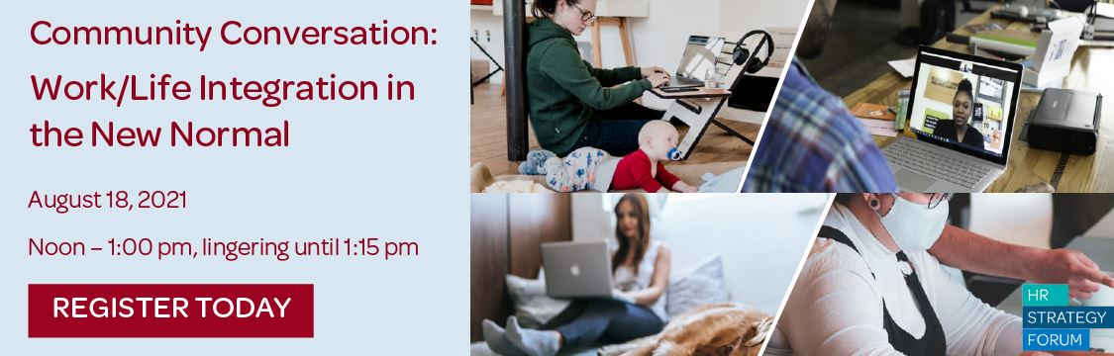
Leveraging from our May program about remaking culture in the new normal, we will explore together how we grapple with work/life integration in the “new normal” work environment. As the pandemic continues with its ups and downs, employees are requesting more flexibility to work from anywhere. Work-from-home mandates have accelerated the digital transformation -- through advances in remote collaboration tools and video conferencing, most office work can be done well from anywhere.
This blurring of lines between work and home, has introduced us now to each other's family and pets, and our home environment. And we like that! Employees now are demanding the flexibility to do work and life in a much more integrated manner.
- How do we create a state of inclusion wherever our people are?
- Is it really true that teams thrive more by being together and enabling collaboration and its resulting innovations? If so, what are the implications for the workforce? If not, how do we accommodate the hybrid environment to build strong teams?
- How do we accommodate more employee flexibility with the emerging business demands?
- How do leaders need to adapt in this hybrid environment?
- Retaining top talent is harder with employees being recruited to “WFA” companies. How can we respond?
In this session you will have an opportunity to discuss with your peers the following...
- How employers are adapting their policies and practices to achieve the best outcomes for both company and employee
- How employees can better manage boundaries to ensure balance between the demands of work and personal needs
- The top three most critical decisions your company will need to make to remain competitive while providing the flexibility employees expect
This will be the focus of our next Community Conversation as we come together to share experiments, challenges, successes and opportunities. Join with fellow HR leaders to share our ideas, questions and learnings. It’s guaranteed to be an interesting conversation.
Relevant articles:
Work Flexibility, Popular With Employees, Is Hardly a Holy Grail
What does a post-pandemic work-life balance look like?
Lack of Flex Arrangements Keep Moms from Returning to Work
What employees are saying about the future of remote work
COVID-19 and the employee experience: How leaders can seize the moment
Let’s Leave the Armor Off for Good, Shall We?
The Covid Fear Isn’t Going Anywhere for a While
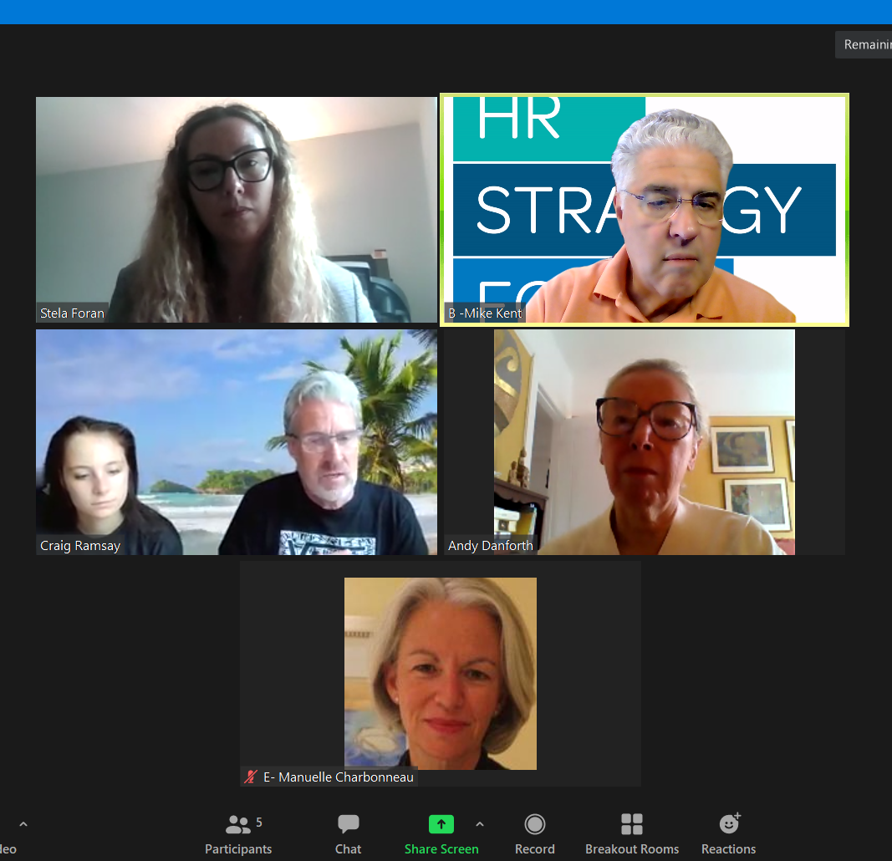
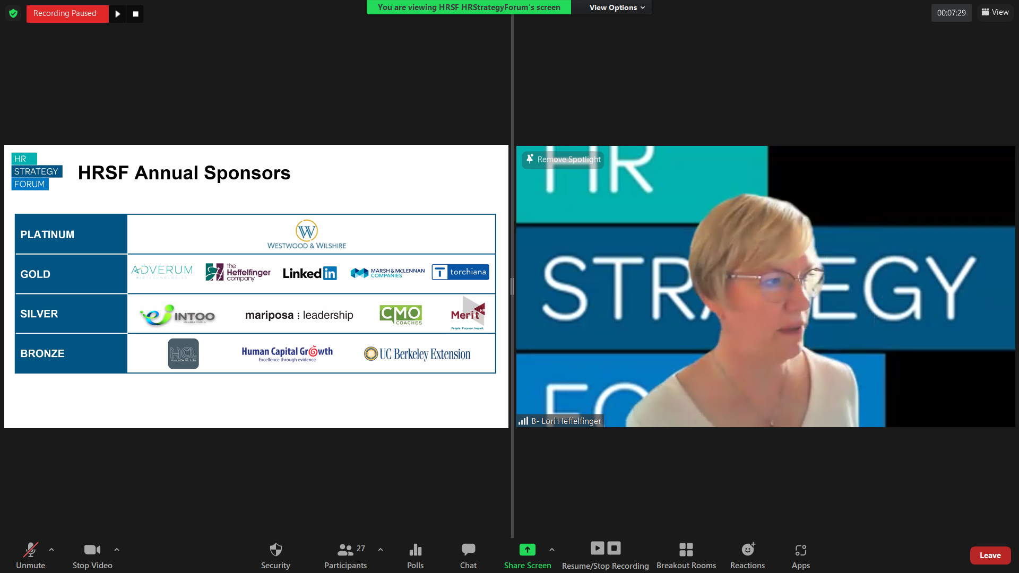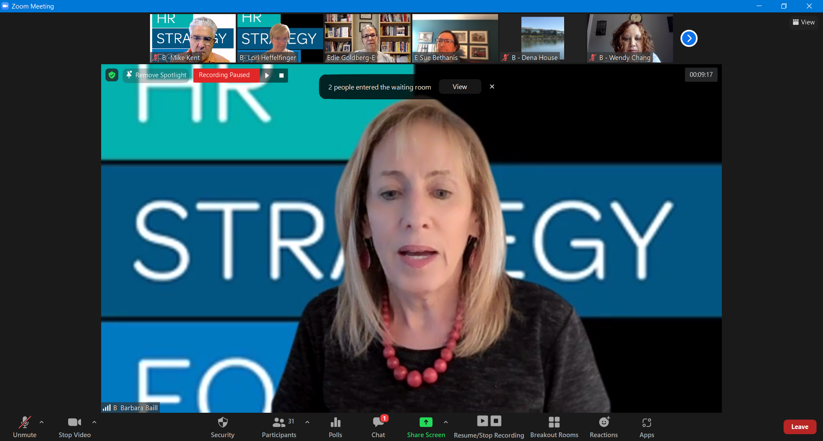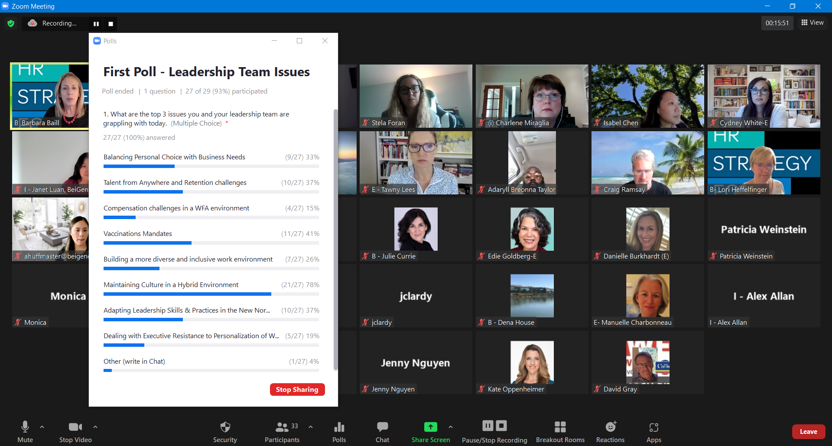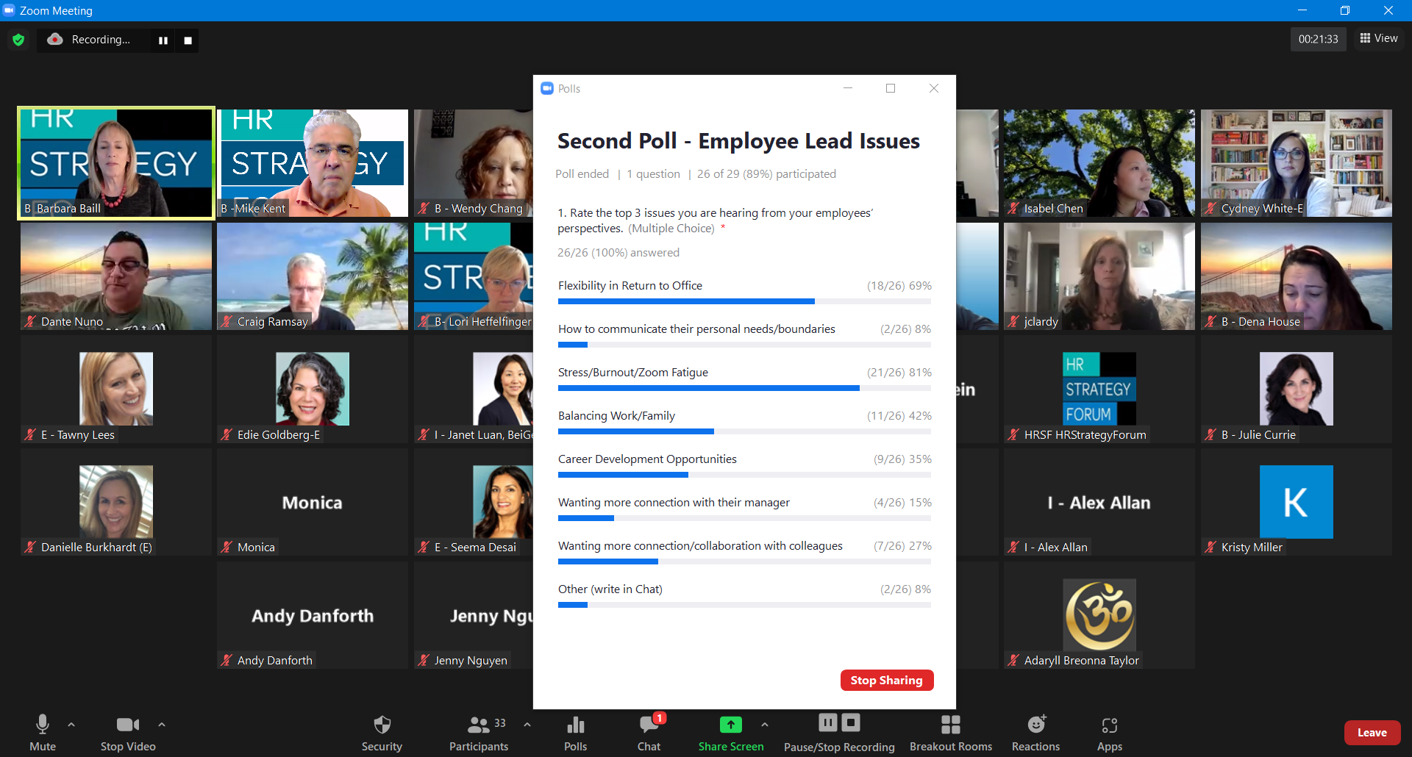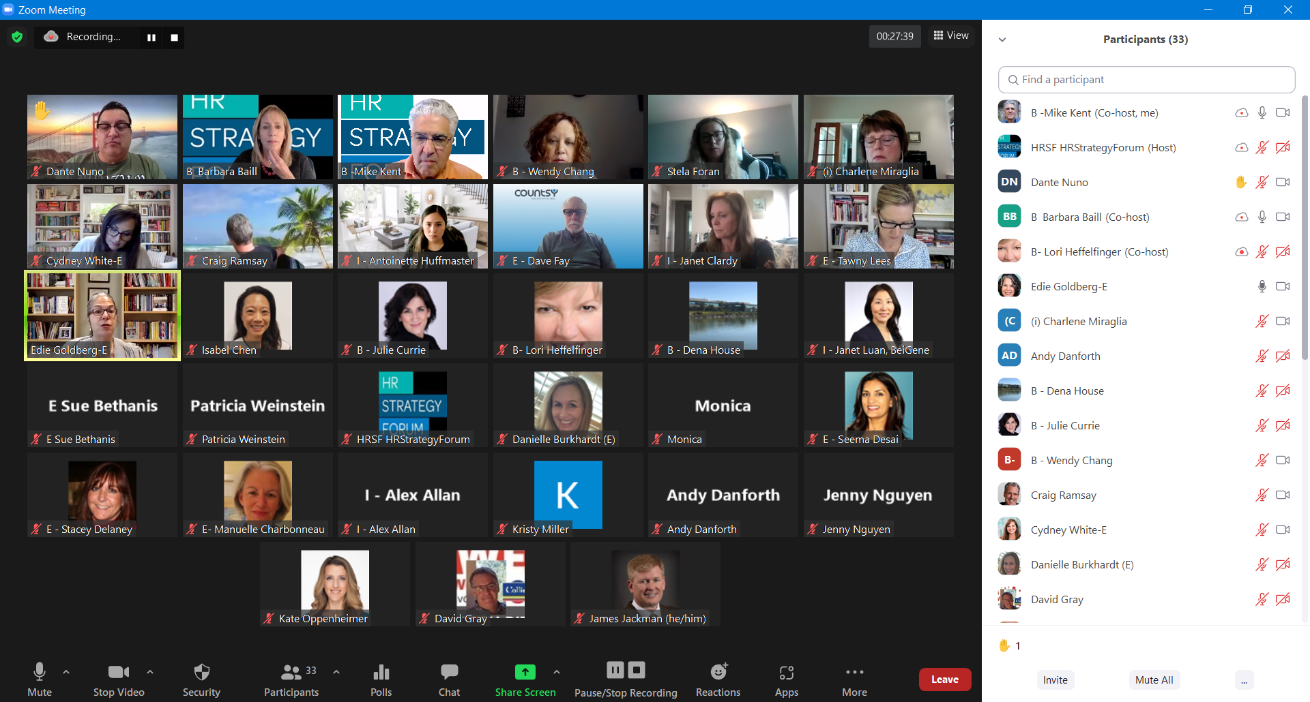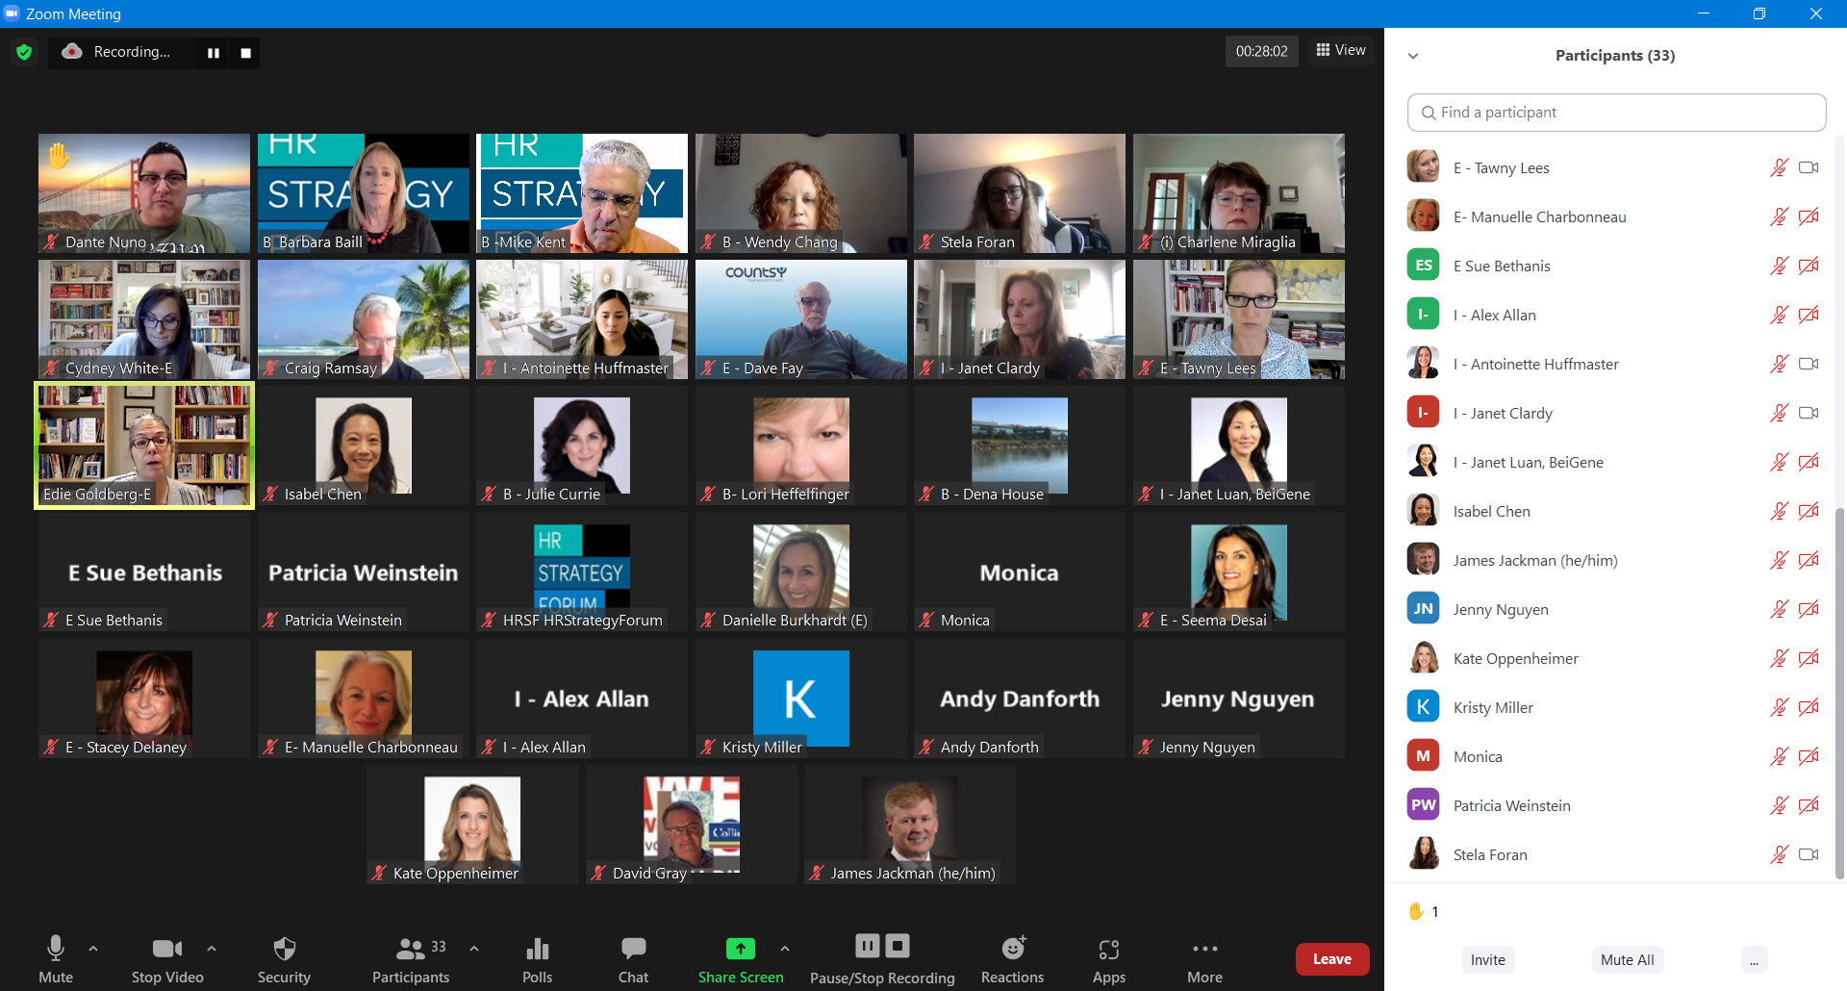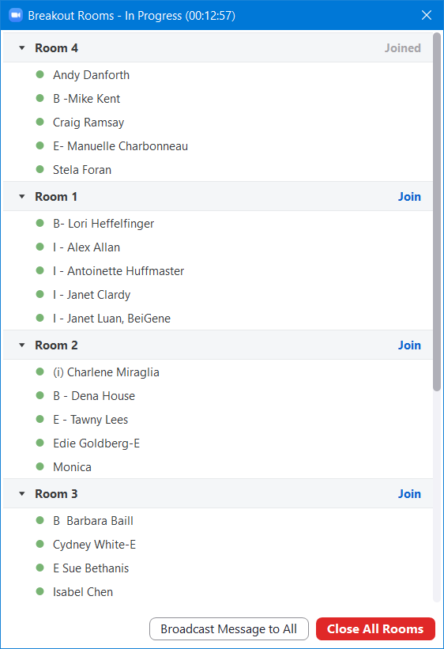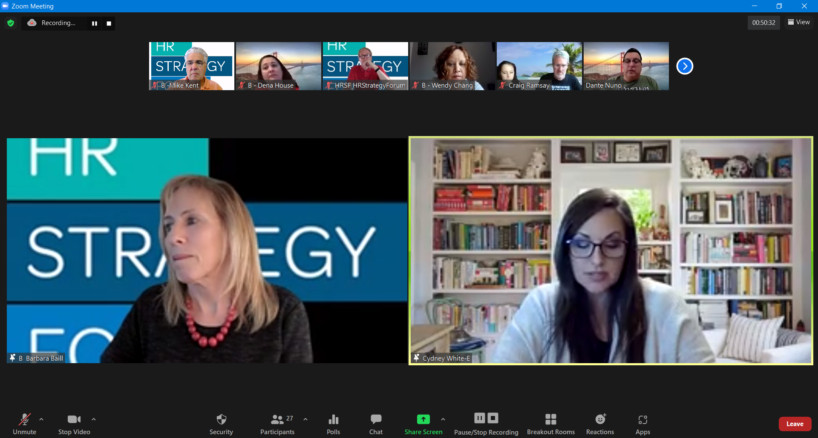
Breakout Group 4

Chat Transcript, HRSF Program, August 18, 2021, Community Conversation – Work-Life Integration in the New Normal

12:02:12 From Barbara Baill - B to Everyone:
input your name, company, email (if comfortable) and whether you are internal HR or external to a corporation
12:02:46 From Charlene Miraglia to Everyone:
Charlene Miraglia, CannonDesign, cmiraglia@cannondesign.com, Internal HR
12:03:16 From Cydney White to Everyone:
Cydney White, (Between roles - starting my new gig on Monday), cydneyewhite@gmail.com, External, HR
12:03:19 From Dave Fay to Everyone: Hi Dave Fay here. I'm a CPO with Countsy, which means external. We provide
HR and Finance services to start-ups.
12:03:32 From Isabel Chen to Everyone: Hello everyone. Isabel Chen, Five9, internal HR.
12:03:34 From Seema Desai to Everyone: Seema - Countsy. I work with David Fay. External HR Consultant
12:03:58 From Stacey Delaney to Everyone: Hello All! I am Stacey Delaney and work with David.
12:04:05 From Dante Nuno to Everyone: Mise En Placement, miseenplacement1@gmail.com, external HR
12:04:06 From Manuelle Charbonneau to Everyone:
Manuelle Charbonneau (E), Manuelle@CharbonneauLeadership.com, executive coach in global companies
12:04:22 From Edie Goldberg-E to Everyone: Hi everyone! I am Edie Goldberg, former President of HRSF/HRPS.
HR/Talent Management.Future of Work Consultant in Silicon Valley.
12:04:43 From E - Tawny Lees to Everyone: Howdy, Tawny Lees, Exec Coach and Leader and Mariposa Leadership
12:04:57 From B - Wendy Chang to Everyone: Wendy Chang, Head of People at IdbyDna
12:04:57 From Stela Foran to Everyone: Stela Foran, Westwood and Wilshire, stela@westwoodwilshire.com,
Project Manager interested in HR
12:04:57 From B -Mike Kent to Everyone: HRSF Board Member, Independent Mediator, Executive Coach & HR
Consultant, 30 year HR practitioner and CHRO, mlkent12@gmail.com
12:04:59 From Monica to Everyone: Hi all! Monica Lippis, mlippis@sbcglobal.net, external
12:05:02 From Internal HR: Janet Luan, BeiGene, janet.luan@beigene.com to Everyone:
Hi everyone, so excited to join this and it's a pleasure to meet you all virtually!
12:07:49 From Alex Allan to Everyone: People Ops leader, Diamond Foundry alex.allan@diamondfoundry.com

What word comes to mind when thinking of distant work:
12:09:14 From Edie Goldberg-E to Everyone: Flexibility
12:09:14 From Julie Currie to Everyone: Zoom fatigue
12:09:15 From Alex Allan to Everyone: blurred lines
12:09:15 From Adaryll Breonna Taylor to Everyone: Fullness
12:09:16 From Internal HR: Janet Luan, BeiGene, janet.luan@beigene.com to Everyone: Have time for family
12:09:17 From E - Dave Fay to Everyone: hard to separate
12:09:17 From E - Seema Desai to Everyone: flexible, dynamic
12:09:18 From Jenny Nguyen to Everyone: flexibility
12:09:20 From Craig Ramsay to Everyone: blurry
12:09:20 From Isabel Chen to Everyone: flexibility
12:09:22 From Adaryll Breonna Taylor to Everyone: Wholeness
12:09:23 From B - Wendy Chang to Everyone: flexibility
12:09:24 From Cydney White-E to Everyone: Flexibility
12:09:25 From Stacey Delaney to Everyone: Unknown
12:09:28 From Dante Nuno to Everyone: Flexible schedules, managing personal and professional life
12:09:29 From Andy Danforth to Everyone: need for boundaries
12:09:34 From Adaryll Breonna Taylor to Everyone: Intersectionality
12:09:34 From (i) Charlene Miraglia to Everyone: flexibility, time management
12:09:34 From B - Wendy Chang to Everyone: boundaries
12:09:35 From B- Lori Heffelfinger to Everyone: Personal time
12:09:38 From E Sue Bethanis to Everyone: getting outside as much as possible
12:09:39 From E - Dave Fay to Everyone: work-life gets blurred
12:09:40 From B -Mike Kent to Everyone: On call 24/7
12:09:47 From B - Dena House to Everyone: boundaries and zoom fatigue
12:09:56 From E - Tawny Lees to Everyone: Flex
12:09:57 From E - Tawny Lees to Everyone: Create
12:10:10 From jclardy to Everyone: Need to reinvent what work/life means
12:17:26 From Monica to Everyone: Employees want to have the option choose
12:20:21 From E- Manuelle Charbonneau to Everyone: Leaders concerned about how to maintain inclusion between
people who return and those who won’t (for health reasons for example)
12:21:44 From B - Julie Currie to Everyone: Employees don’t want to come back.
12:22:35 From David Gray to Everyone: We're all somewhat burning out BUT in the hot vertical of Med Device,
interviewees want ability to work remote (significantly)
12:24:28 From David Gray to Everyone: @Cydney comment seems like a corollary to what the tight labor sectors are
seeing
12:29:37 From B Barbara Baill to Everyone: Breakout Group Topics
- How are your addressing the Top 3 Issues companies are dealing with. What successes and challenges are you experiencing?
- What are you doing to address the issues that are arising from your employees? What successes and challenges are you running into?
12:57:00 From E- Manuelle Charbonneau to Everyone:
That was such a valuable hour spent together! Thank you for organizing.
12:57:35 From HRSF HRStrategyForum to Everyone: Interesting articles: https://mariposaleadership.com/wp-
- content/uploads/2021/07/Lets-Leave-the-Armor-Off-for-Good-072321_final.pdf
- https://www.wsj.com/articles/anxiety-covid-delta-variant-
11628796175?st=qrxtsdjjgm984bq&reflink=desktopwebshare_permalink
Breakout Group Topics: - Work Flexibility, Popular With Employees, Is Hardly a Holy Grail
- What does a post-pandemic work-life balance look like?

12:58:18 From (i) Charlene Miraglia to Everyone: I need to run for my next meeting - thank you everyone!
12:58:44 From B - Dena House to Everyone: Thank you. Great Discussion today! Super helpful!
12:58:54 From E - Dave Fay to Everyone: Great session! More time would be great, but have to jump. Thx all!
12:59:00 From B- Lori Heffelfinger to Everyone:
Link to Evaluation: https://insight.humancapitalgrowth.com/index.php/749799?lang=en
12:59:16 From B- Lori Heffelfinger to Everyone: Please also join us for further conversation on Slack
13:00:15 From Craig Ramsay to Everyone: The HRSF Slack Community is here: hrstrategyfor-qib1862.slack.com
13:00:36 From Patricia Weinstein to Everyone: Thank you!
13:00:48 From Danielle Burkhardt (E) to Everyone: Thank you!
13:08:42 From B Barbara Baill to Everyone: Other excellent resources:
- https://mariposaleadership.com/wp-content/uploads/2021/07/Lets-Leave-the-Armor-Off-for-Good-
072321_final.pdf
- https://www.wsj.com/articles/anxiety-covid-delta-variant-
11628796175?st=qrxtsdjjgm984bq&reflink=desktopwebshare_permalink
13:11:18 From E- Manuelle Charbonneau to Everyone:
I am posting a link that compares the desirability of various countries according to expatriates:
https://www.expatexplorer.hsbc.com/survey/country/france/united-states
13:11:35 From B- Lori Heffelfinger to Everyone: Thanks Manuelle!
13:13:15 From B- Lori Heffelfinger to Everyone: hear hear Mike!!!!
13:13:53 From B- Lori Heffelfinger to Everyone: Couldn't agree with you more...Mike. And there ARE a small # of
companies that are "doing good"...
13:19:00 From I - Janet Luan, BeiGene to Everyone: Thank you everyone, have to run to the next meeting, this is really
helpful! Look forward to the next great session!
13:19:07 From Craig Ramsay to Everyone: Thanks for the link Manuelle - fascinating

