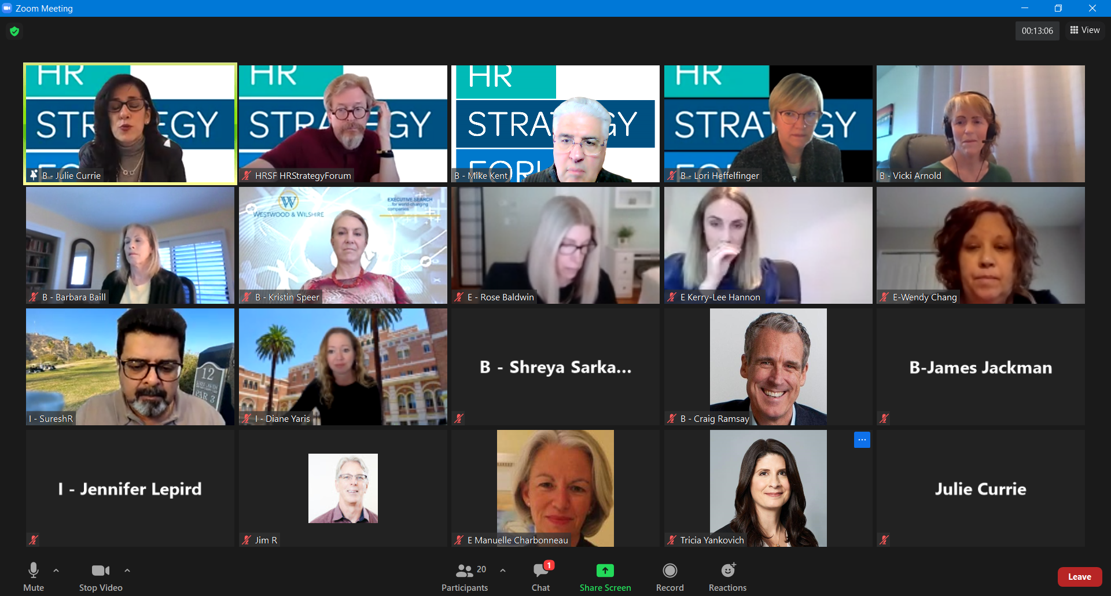

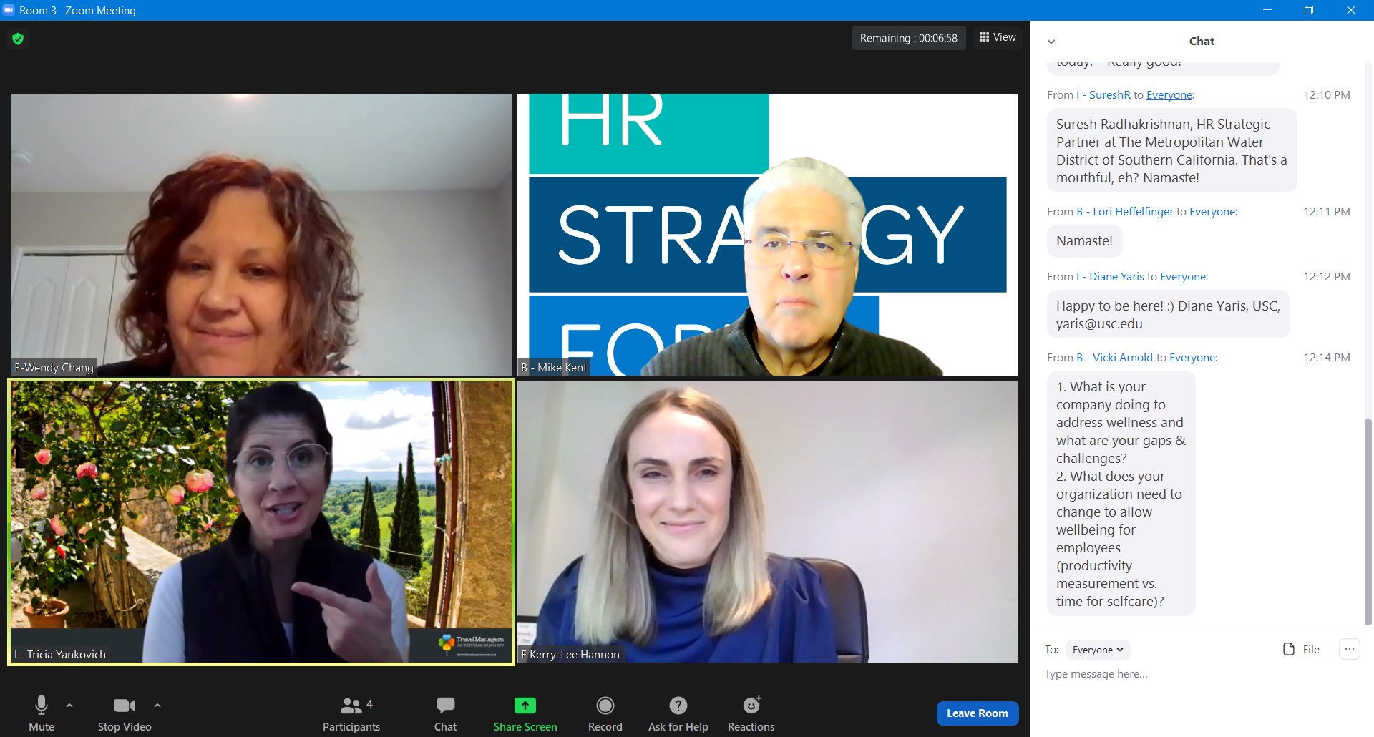
Breakout Group 3

Chat Transcript
12:01:41 From B - Lori Heffelfinger to Everyone : Everyone, please change your names (top right corner of your picture) - click on 3 dots and then rename.
12:02:17 From B - Barbara Baill to Everyone : Please change your name. Put an I if you are part of an corporation or E if you are an external consultant/vendor. Ex: I-Jane Doe.
12:03:09 From HRSF HRStrategyForum to Everyone : ● www.menti.com code 91 05 75 6
12:06:26 From B - Barbara Baill to Everyone : Zoom Fatigue
12:06:27 From E - Rose Baldwin to Everyone : Mindfulness
12:07:08 From B - Vicki Arnold to Everyone : Please change your name and put I for internal or E for external in front of your name.
12:08:17 From I - SureshR to Everyone : And what's B for? before the names?
12:08:24 From B - Lori Heffelfinger to Everyone : Board Members
12:08:31 From B - Vicki Arnold to Everyone : B is for board members
12:08:48 From B - Lori Heffelfinger to Everyone : Hi Tricia
12:08:59 From B - Lori Heffelfinger to Everyone : Hi Jennifer and Jim
12:09:03 From B - Vicki Arnold to Everyone : Please introduce yourself in chat - name, company and, if you feel comfortable, your email address.
12:10:01 From B - Lori Heffelfinger to Everyone : Hi Diane! So good to see your here today. Really good!
12:10:43 From I - SureshR to Everyone : Suresh Radhakrishnan, HR Strategic Partner at The Metropolitan Water District of Southern California. That's a mouthful, eh? Namaste!
12:11:09 From B - Lori Heffelfinger to Everyone : Namaste!
12:12:13 From I - Diane Yaris to Everyone : Happy to be here! :) Diane Yaris, USC, yaris@usc.edu
12:14:01 From B - Vicki Arnold to Everyone : 1. What is your
company doing to address wellness and what are your gaps & challenges?
2. What does your organization need to change to allow wellbeing for employees (productivity
measurement vs. time for selfcare)?
12:34:58 From B - Kristin Speer to Everyone : I need to hop off, have really enjoyed this!
12:36:08 From B - Vicki Arnold to Everyone : Feel free to start dropping the thoughts from your breakout groups here in the chat. We may not get to everyone.
12:38:42 From E Manuelle Charbonneau to Everyone : we discussed a gifting service called Gifted.co to provide small tokens of recognition to employees.
12:39:34 From B - Vicki Arnold to Everyone : Didn't mention in our group but we are implementing Meeting Free Fridays.
12:40:49 From I - SureshR to Everyone : That sounds interesting, Manuelle. We have the Metstore - where ee's can get stuff. No gifting there though.
12:41:05 From E Manuelle Charbonneau to Everyone : we also discussed the pros and cons of unlimited time off. it may look great, but the reality is that people take LESS time off when it is « unlimited »12:41:50 From I - SureshR to Everyone : Love Meeting Free Days!!!
12:41:58 From B - Julie Currie to Everyone : Me too!
12:43:05 From E Manuelle Charbonneau to Everyone : I like the expanded EAP! my clients need this.
12:43:43 From B - Kristin Speer to Everyone : We've found using https://gifted.co/ is nice - HR can even set up budgets for managers to use as they see fit, and you can pre-set gifts for standard dates (birthdays, Valentine's, etc). Great little company.
12:43:51 From Jennifer Troia to Everyone : I haven't found "unlimited" vacation to be utilized less than before, that is, until COVID. People are not going anywhere so they keep working. We need to encourage staycations.
12:46:51 From Dave Fay to Everyone : I met a guy named Ben Stokes who started a company named Social Table. They do online events with teams/companies where they all get 2 bottles of wine delivered to their homes prior to the event and then they facilitate the event with story telling, a somalier to discuss the wines, etc. Mostly a social thing but kind of cool.
12:47:52 From B - Vicki Arnold to Everyone : Lots of great ideas here!
12:52:16 From I - SureshR to Everyone : Love the fantastic ideas for wellness. Very partial to anything involving wine. Thank you Dave Fay. And Tricia's background photo - awesome. Is that ur backyard?
12:53:16 From E Manuelle Charbonneau to Everyone : thank you for the amazing contributions!
12:53:45 From Dave Fay to Everyone : Lots of great sharing. Thanks all!
From I - SureshR to Everyone: 12:54 PM
I need to jump off to another meeting. Thank you HRSF Board - and Prez Lori and First Gentleman Jack!!!
From E - Rose Baldwin to Everyone: 12:55 PM
Can you share the link to this article in chat
From I - Tricia Yankovich to Everyone: 12:56 PM
To address my personal burnout - I'm investing in my fitness. Putting time on my calendar each week to run/ do yoga and staying committed to that. It has helped me tremendously and I share with my team to empower them to take the time during the work day to do movement.
From B - Lori Heffelfinger to Everyone: 12:57 PM
Aerobic exercise is helpful for me and getting outside and the Sun AND now spending time with friends/family outside.
From Me to Everyone: 12:57 PM
The link to the NYT article is at the bottom of the page for this event on our website.
From I - SureshR to Everyone: 12:57 PM
Stay healthy and Happy! Have fun in 2021.
From B - Lori Heffelfinger to Everyone: 12:58 PM
👋 Let’s move this to Slack! We’ve got 83 folks from the team there already. You can sign up here: https://join.slack.com/t/hrstrategyfor-qib1862/shared_invite/zt-msb8lqia-qTRziDGtfk~6q8a9QxBPdg
From Jennifer Troia to Everyone: 12:58 PM
I am off to another meeting - thank you!

